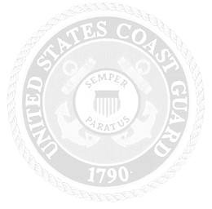
CERTIFICATE OF RETIREMENT

FROM THE ARMED FORCES OF THE UNITED STATES OF AMERICA

TO ALL WHO SHALL SEE THESE PRESENTS, GREETINGS:
THIS IS TO CERTIFY THAT

«RANK/GRADE»
«MEMBER NAME»

HAVING BEEN RETIRED AFTER HONORABLE SERVICE
IN THE

UNITED STATES COAST GUARD

IS AWARDED THIS TESTIMONIAL AS AN
ACKNOWLEDGMENT OF DUTY FAITHFULLY PERFORMED
DURING A PERIOD OF OVER «YRS» YEARS
DONE AT WASHINGTON, DC THIS «DAYS» DAY
OF «MONTH» IN THE YEAR OF OUR LORD

TWO THOUSAND AND «YEAR»

________________________________
LINDA L. FAGAN
ADMIRAL, U.S. COAST GUARD
COMMANDANT

