AY24 RESERVE POTENTIAL SHOPPING LIST VALIDATION AND COMMAND CONCERNS
**Please read this document in its entirety before drafting your unit’s Command Concerns**
1. POTENTIAL SHOPPING LIST (PSL): The PSL consists of billets that are expected to be filled during Assignment Year 2024 (AY24). Positions that should be shopped include:
- Positions occupied by an incumbent who is tour complete or has an approved retirement or separation in 2024.
- Current vacant positions.
- Any new or reprogrammed positions via the PRR process.
2. COMMAND CONCERNS: Command Concerns are the primary means for Commands to provide assignment needs to RPM. During the assignment process, every effort is made to address unit concerns while ensuring Service needs are met. Command Concerns should address the following:
- Extension requests
- Anticipated ADOS
- Members in a pay grade mismatch (greater than +/- 1 for officers, +/- 2 for enlisted members)
- Members eligible/approaching retirement (reaching age 60 or 30 years of service) in 2024
- Multi-encumbered positions
- PAL discrepancies (PRR/REDUX, members in wrong positions, etc.)
- HYT candidates
- Any holistic assignment concerns (e.g., unit is losing 2/3 of dept this transfer season)

**Please note the following**
- Command Concerns should not address individual member reassignment desires. The mechanism for this process is solely through the E-Resume endorsement.
- When feasible, units should submit consolidated Command Concerns for the entire Unit. For example, Base Boston has the option to submit Command Concerns as a consolidated report for its 35 subordinate departments by using DEPT ID 041661. However, this may not be suitable for all units.
- The only acceptable format for Command Concerns is via the ‘Positions at Department’ export from Direct Access which can be completed using the attached instructions (AY24 Reserve Command Concerns Instructions).
- All Command Concerns should be submitted to RPM NLT 27 OCT 2023.

PSC-RPM-2 GENERAL INFORMATION
3. WHAT WE DO: ‘People’ discrepancies. Contact the appropriate AO with questions regarding:
- Members who are not in the correct billets on the PAL.
- Members who are assigned to a billet at a particular unit, but are not showing up on the unit PAL.
4. WHAT WE DON’T DO: ‘Billet’ discrepancies; particularly billets shown on the Unit PAL that don’t match the actual Unit organization. These issues should be addressed with District, Area, or HQ resource managers.
Note: PSC-RPM does not have the ability to create, move or delete billets.
AY24 RESERVE COMMAND CONCERNS INSTRUCTIONS
1. PSC-RPM-2 has standardized the validation template by using the ‘Positions at Department’ feature in Direct Access.
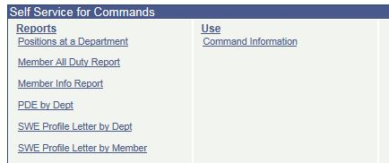

2. Enter your DEPT ID and click ‘View Results’.
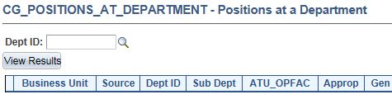
3. Export the department information into Excel.
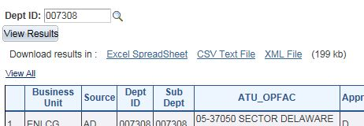

4. Delete the column labeled ‘Intention to Shop Member’.
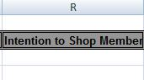

5. Create one additional column labeled ‘Command Concerns’.
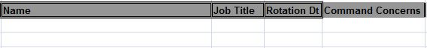

6. Unit POCs should validate the information in the column labeled ‘Intention to Shop Position’.
**Validation of E-6/below billets is not required unless the incumbent intends to compete for a new assignment**
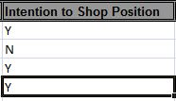
7. Communicate amplifying or relevant information to PSC-RPM-2 ONLY in the user added column (Command Concerns).
8. If you find significant discrepancies between what you believe should be advertised and the intentions of PSC-RPM-2, you should review your Unit PAL for accuracy of body/billet matches. Access to the Unit PAL can be found using the ePAL feature in CGBI.
9. Once complete, save the document as ‘(Unit Name)-AY24 Command Concerns’ (e.g. Sector Charleston-AY24 Command Concerns) and email as an attachment to:
HQS-SMB-CGPSC-RPM-2-ASSIGNMENTS@uscg.mil

